

APPLICANT ORGANISATION

ORGANISATION REPRESENTATIVE

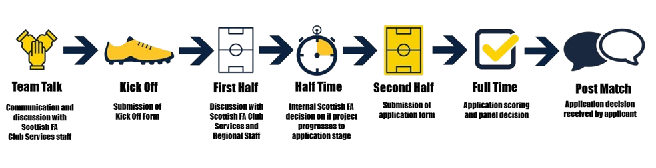
OUR PROCESS AT A GLANCE:


Team Talk is the initial conversation with the relevant Scottish FA staff. This is the first contact to give the Scottish FA initial information on your project.

Our “Kick Off” form is an initial form that allows us to gather more information around your project. This is a short form that asks for basic information only.
Following receipt of your “Kick Off” form, we will contact you to discuss the content in more detail. This will take the form of an online call or in person visit.

If your project is ready for an application to the fund, we will send you a copy of the application form. If you are not ready at this stage, we will support you for future application windows.
Once you have received an application form from us, you will have a set period to complete this and return it to us. This timeframe will be communicated with you at this point.
When our application window closes, all applications will then be scored and put towards an application panel who will make a funding decision.
Following the application panel, we will relay the panel’s decision to you with a decision letter. Those that are successful will then receive a grant offer letter when appropriate.

COMPLETING THIS FORM
Please note that this form DOES NOT CONSTITUTE A FULL APPLICATION to The Scottish Football Facilities Fund.
By submitting this form, you are completing the first stage in making a formal application to the fund. You will still be required to submit further detailed information by the application deadline if you wish your project to be considered for funding.
The “Kick Off” form is part of our process and allows Scottish FA Club Services staff to collate initial information on projects before contacting lead applicants to discuss the content of the form. This takes place in advance of a full application submission, allowing for any missing details or amendments to be considered. This is a critical step in ensuring applications include all key information and avoid, as far as possible, anything which could lead to an application being rejected at the point of initial assessment.
The information provided in the “Kick Off” form will also assist with the completion of a full application. The initial information will be supplemented with more detailed information following a conversation with the relevant Club Services member of staff listed below.
Your organisation status will determine the information that will be required following the conversation with the relevant Club Services member of staff.

Please see contact details below for your relevant Club Services member of staff:

For Scottish FA Member Clubs contact:
- Kris Wales - kris.wales@scottishfa.co.uk or on 07706 296118

For Central, West, or South West Regional Community Football Spaces projects, contact:
- Nathan Ross - nathan.ross@scottishfa.co.uk or on 07974 047740

For North, East, or South East Regional Community Football Spaces projects, contact:
- Blair Sutherland - blair.sutherland@scottishfa.co.uk or on 07079 741170

Please email your completed Kick Off form to - facilities.kickoff@scottishfa.co.uk

Any questions related to your Kick Off form should be sent to your relevant contact above. In the email subject line, please enter ‘Kick Off Questions’ followed by the name of the Applicant Organisation as it appears on the first page of this form above. For example, ‘Kick Off Questions – ‘Raggy Rovers FC’. This makes it easier for us to prioritise your email in what can be a heavily inundated mailbox at certain points in the football season/calendar year.

This icon notes important information at this section of the form. Please read this information carefully.

- ABOUT THE APPLICANT

1.1 OFFICIAL NAME OF APPLICANT ORGANISATION

1.2 ORGANISATION REPRESENTATIVE
Who is filling out this form? The phone number and email address added here will be the main points of contact. Please delete all example/help text before completing.
Applicant Full Name | Contact Number | Email Address
Position within Organisation

1.3 SECONDARY ORGANISATION REPRESENTATIVE
Applicant Full Name | Contact Number | Email Address
Position within Organisation

1.4 ORGANISATION ADDRESS
MAIN ADDRESS OF ORGANISATION
Name of Location*
First Line of Address
Second Line of Address
Town/City
Local Authority - Choose an item.
Postcode
* Please include the location’s main function i.e., Club, HQ, Sports Facility, Pitches, School etc.

1.5 SCOTTISH FA MEMBERSHIP STATUS

Scottish FA Member Clubs are those that hold a Club Licensing level.
Community and grassroots club do not need to fill in this section.
Please continue to question 1.6.
NAME OF CLUB | CLUB LICENSING ACCREDITATION
 | Choose an item.

If you are a member club does your project involve a wider grassroots community football impact / activity? | Choose an item.

1.6 LEAD PARTNER CLUB
Please provide information about the highest Quality Mark partner club that uses the facility – only mention the project that will directly be supported by the investment applied for. Please ensure that your Quality Mark accreditation(s) are live. To reinstate, please contact your SFA Regional Manager.
Member Clubs who are not applying for a community project do not need to fill in this section. Please continue to question 2.1
1.6.1 Lead Partner Club | NAME
1.6.2 Quality Mark Accreditation | Choose an item.

1.7 ADDITIONAL PARTNER CLUBS
Please provide additional names of partner clubs that use the facility - please only mention the project that will directly be supported by the investment applied for.
Member Clubs who are not applying for a community project do not need to fill in this section. Please continue to question 2.1
NAME OF CLUB | QUALITY MARK ACCREDITATION
 | Choose an item.
 | Choose an item.
 | Choose an item.
 | Choose an item.

- ABOUT THE PROJECT

2.1 - PROJECT LOCATION
Please provide the location of the intended project - this is the main site that the project directly supported by the investment will operate from. Please don’t include any ‘satellite’ sites.
Please delete all example text before populating the fields below.
LOCATION OF PROJECT
Name of Location
First Line of Address
Second Line of Address
Town/City
Local Authority - Choose an item.
Postcode


2.2 - PROJECT TYPE – COMMUNITY FOOTBALL PROJECTS
Please tick the PROJECT TYPE box to highlight which project you are applying for and choose your specific PROJECT ELEMENT from the dropdown menus beside each tick box.
If your project involves multiple PROJECT ELEMENTS, please ensure all are included below.
Member Clubs who are not applying for a community project do not need to fill in this section. Please continue to question 2.3
PROJECT TYPE |  | PROJECT ELEMENTS
On Pitch | ☐ | Choose an item. | Choose an item. | Choose an item. | Choose an item.
Off Pitch | ☐ | Choose an item. | Choose an item. | Choose an item. | Choose an item.
If other, please give details.

2.3 - PROJECT TYPE – MEMBER CLUBS

Please tick the PROJECT TYPE box to highlight which project you are applying for and choose your specific PROJECT ELEMENT from the dropdown menus beside each tick box.
If your project involves multiple PROJECT ELEMENTS, please ensure all are included below.
Community and grassroots club do not need to fill in this section. Please continue to question 2.4
PROJECT TYPE |  | PROJECT ELEMENTS
Club Licensing | ☐ | Choose an item. | Choose an item. | Choose an item. | Choose an item.
If other, please give details.

2.4 PROJECT INFORMATION
Please use the space below to outline your project. This information should be directly attributed to the project type and elements selected above.
Please delete all example text before filling out the below.
Max 300 words.

- FINANCE AND FUNDING
3.1 - TOTAL PROJECT COST
Please provide the total cost of this project. (This should include VAT)
TOTAL COST OF THE PROJECT. | £00.00

3.2 - FUND REQUEST
If your application is successful, the approved level of funding will be based on an assessment of financial need.
TOTAL FUNDING REQUEST TO THE SCOTTISH FA | £00.00


3.3 - PARTNER FUNDING
Projects with no partner funding and a 100% funding request will be REJECTED.
This fund operates on an initial funding principle of 50/50 split with partner funding. At the time of application, we will require evidence of confirmed partner funding.
3.3.1 TOTAL CONFIRMED PARTNER FUNDING | £00.00

3.3.2 TOTAL UNCONFIRMED PARTNER FUNDING | £00.00

3.3.3 TOTAL FUNDING GAP (IF ANY) – THIS SHOULD BE TOTAL PROJECT COST MINUS ANY CONFIRMED OR UNCONFIRMED FUNDING | £00.00

