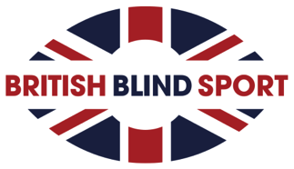
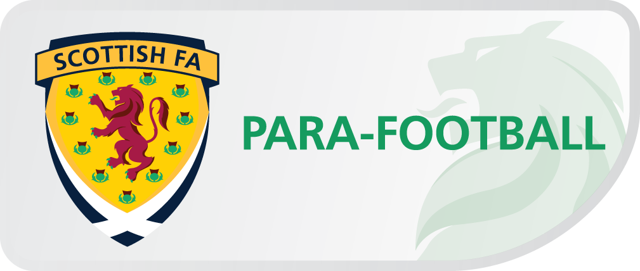
Coaching Footballers with a Visual Impairment
- A guide for supporting Visually Impaired Adults and Children in Football

Contents
1 Title page
2 Contents
3 Introduction
4 Contributor Testimonials
5-8 Understanding Visual Impairments
- The Facts
- Terminology
- Eye Condition Examples
8-11 Encouraging Participation
- Advertising
- Travel
- First Contact Information
- Staff
- Session Venue and Time
- Guide Dogs
- Girls and Women
- Positive Communication
  - Guiding Techniques
13-16 Supporting Visually Impaired Footballers
- Coaching Visually Impaired Footballers
- General Coaching Advice
- Supporting Partially Sighted Footballers
- Supporting Blind Footballers
- Orientation and Spatial Awareness
17-18 Competitive Visually Impaired Football
- Rule adaptations
- Selecting the Correct Version of the Game
18-20 Classification
- Domestic
- International
21 Scottish FA Long Term Player Development Model
  - Safe Football
- Safety Considerations
- Safeguarding Children, Young People and Vulnerable Adults
- Clean Sport/Anti-doping
25 Summary and Best Practice
26 Further Reading
27-28 About British Blind Sport and the Scottish Football Association

Introduction

Welcome to the British Blind Sport Coaching Visually Impaired Footballers ‘A Guide for Supporting Visually Impaired Adults and Children in Football’ produced in partnership with the Scottish Football Association.

At British Blind Sport we believe that every person with a visual impairment (VI) has the right to participate in sport and physical activity. We understand that there are many hurdles and barriers to over-come in order for each and every person living with sight loss to have the same accessibility to sport as a sighted person. This resource has been created with the specific purpose to assist anyone who is delivering football activities with support, ideas and guidance on how to include people with a visual impairment.

This resource is all about helping sport providers to be VI friendly through their provision of activities, training, resources and support. These include:
- Coaches
- PE Teachers
- Community coaches
- Multi-sport/Multi-skill coaches
- Volunteers
- Sport development professionals

This resource will enable coaches, teachers and parents/carers to:
• Learn about sight loss and eye conditions
• Have a better understanding of the needs of people with a visual impairment
• Apply their knowledge to meet the needs of people with a visual impairment
• Use basic communication skills to support the needs of people with a visual impairment in sport and physical activity
• Understand where you can obtain further support to ensure your club/group is fully accessible and inclusive to people with a visual impairment

By making small and simple adaptations you will be able to include people with a visual impairment in your sports and activity sessions. The information and tips that you will find in this resource will be beneficial to all the participants in your group, not just people with a visual impairment.

Alaina MacGregor – Chief Executive Officer, British Blind Sport
“British Blind Sport is committed to providing sport and recreational opportunities for all blind and partially sighted adults and children across Great Britain from grassroots to elite level. Sport is often the springboard to developing new opportunities, health benefits, new friendships and renewed confidence. The positive effects of participation in sport for a visually impaired person cannot be underestimated and we are aware that skilled coaches and teachers make all the difference to helping others achieve their goals. This resource is a fantastic tool for those who are committed to making a visible difference through sport.”

Andrew Gould- Scottish FA Head of Regional Development

The Scottish Football Association is delighted to work in partnership with British Blind Sport to create the Coaching Footballers with a Visual Impairment – A guide for supporting Visually Impaired adults and children in Football. This resource as part of the Scottish FA Para-Football strategy “PlayAbility…Our Game is the Same 2017-2022” allows the Scottish FA to continue to support coaches working within Para-Football and the mainstream game enabling Visually Impaired Footballers to access the National Sport, enjoy the benefits of football and have the opportunity to reach their full potential.

Understanding Visual Impairments

The Facts

There are almost two million people in the UK living with sight loss. This figure includes approximately 365,000 people registered as blind or partially sighted in the UK, of which over 25,000 blind and partially sighted children (aged 0-16).

The number of people in the UK with sight loss is set to increase in line with the ageing population: by 2050 the number of people with sight loss in the UK is likely to be around four million.

Terminology

Sight is classified in more than one measure. The main measures are ‘visual acuity’ and ‘visual field’.

Visual acuity is a person’s ability to see fine detail.

Visual field is the boundaries of what a person can see in one instant i.e. the entire area which can be seen without moving the eyes.

There is often confusion between the terms blind, visually impaired and partially sighted.

Visual impairment is an umbrella term broken down into two main categories; severely sight impaired and sight impaired.

Severely sight impaired

This category is also known as blind.
• Under government legislation, a person who is severely sight impaired would be unable to perform a job for which eyesight is an essential element for the task.
• They will not be able to see a demonstration.
• They may become quickly disorientated during an activity.

Sight impaired

This category is also known as partially sighted.
• Partially sighted people will have some useful vision that they can use to navigate the world.
• They may not be able to see a demonstration.
• They may not be able to recognise you from a distance.

Severely sight impaired (blind) and sight impaired (partially sighted) are collectively known as visually impaired.

Eye Condition Examples

There are a number of conditions that result in a visual impairment. These varying conditions affect people in different ways. For example, one person may be totally blind and unable to perceive any visual input, whilst another may have blurred peripheral vision but good central vision. There are four conditions that cause the majority of sight loss, and some information about these is provided below. However, it is important to remember that everybody has different levels of vision and varying support needs; the crucial thing is to discuss this directly with the participant and develop an understanding of their visual impairment and its effects.

Macular Degeneration
Macular degeneration affects a small part of the retina at the back of the eye called the macular. It causes loss of vision in the centre of the visual field, affecting vision when looking directly at something. People with this condition will usually have peripheral vision, but may struggle to recognise faces, e.g. of their fellow participants or coaches.

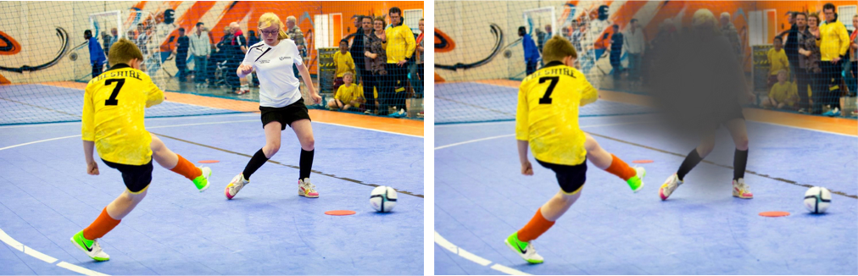

Glaucoma
Glaucoma causes a loss of peripheral vision due to damage to the optic nerve or increased eye pressure. This occurs gradually but will result in a significant reduction of peripheral vision over time. While treatment exists for glaucoma, it cannot repair existing sight loss.

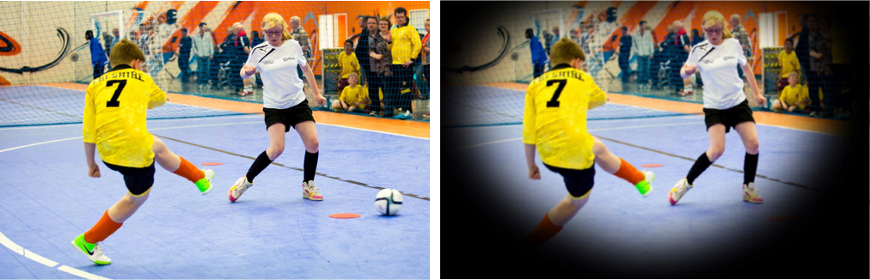

Cataracts
Cataracts cause blurred or cloudy vision as result of yellowy pigment on the lens of the eyes. This condition is the main cause of visual impairment across the globe. To treat cataracts, surgery can remove the cloudy lens.

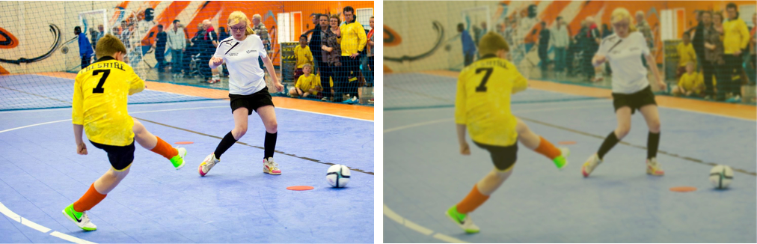

Diabetic Retinopathy
Diabetic retinopathy can affect anyone with diabetes. It causes floaters and blurred vision, resulting from damage to the retina due to high blood sugar levels.

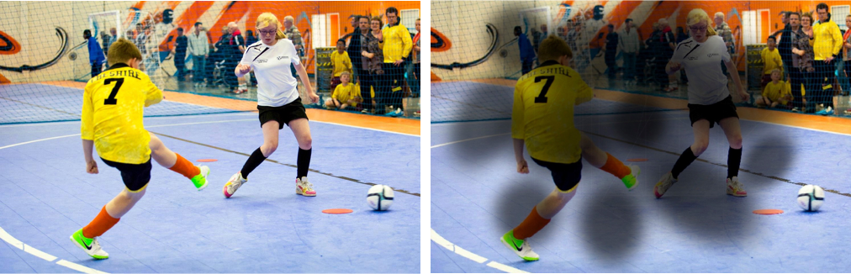

Other conditions
Along with these four conditions, there are many other causes of sight loss. Visit the RNIB website for information on a specific eye condition.

http://www.rnib.org.uk/eye-health/eye-conditions

Encouraging Participation

This section will outline some key factors to consider when planning and delivering football activities for people with a visual impairment, which will help ensure a quality experience for both providers and participants.

Advertising

The promotion and marketing of your sessions, training events, and activities ensures that people are aware of what your club offers, where you are located, how to get there by public transport and that you are accessible.
To ensure that your advertising is accessible and welcoming to visually impaired communities, consider the following:

- Provide information in alternative formats if required (e.g. braille, plain text without images, or suitable electronic version for a screen reader). For help finding a suitable braillist, please contact British Blind Sport or Scottish Disability Sport.
- Advertise your sessions with local and national visually impaired organisations such as British Blind Sport, RNIB, eye health hospitals or your local sight loss charity.
- Many local authorities provide a sight or sensory support service. This can be an excellent method to promote your club or sessions and engage with visually impaired communities. British Blind Sport can advise on your local contacts, contact British Blind Sport for further information.
- Use social media to promote your services as most platforms are very accessible and popular medium for visually impaired communities.
- Consider using images of visually impaired participants in your marketing material. A lack of diverse and inclusive images in marketing material can be a barrier to visually impaired people registering for sporting activities.

Travel

Another key barrier to participation for people with visual impairments is travel. As many visually impaired people rely heavily on public transport, it is advisable to check public transport options and promote the nearest train station or bus route in any promotional or marketing material. Additionally, there may be community transport options available, local sight support services can provide information on available services. Some participants may rely on a sighted guide or support worker to assist with transport to and from your activity. To find your local sight support services please contact British Blind Sport.

First Contact Information
In addition to the general information you would discuss with all new participants, consider also discussing the following:
- Transport arrangements.
- Whether another person or a guide dog will also be attending.
- Any previous experience or knowledge of football. Have they seen football before?
- Motivations and goals for taking up football.
- Any worries or concerns.
It might be necessary to provide a meet and greet service, especially on a first visit to a session or event.

Staff

It is important that all volunteers and members of staff taking public enquiries are aware that your club and activities are accessible to visually impaired people. It is recommended that a document providing visually impaired guidance is readily available, which includes information on facility access, guide dog arrangements, public transport links, and the first steps to taking part.
If possible, offer volunteers and staff Para-Football awareness training; contact Scottish FA for further information.

Session venue and time
- Consider the impact of daylight on some eye conditions and organise sessions in good daylight where possible.
- Partially sighted football sessions are best played in an indoor environment. This allows for better contrast and lighting.
- Check that the playing surface is suitable with high colour contrast.
- Blind football sessions are best played outdoors. This allows for better acoustics.
Guide Dogs
Some visually impaired participants may have guide dogs. Identify the best location at the venue where the guide dog can rest, whilst the owner is participating. The best location is usually the reception or offices, where the dog can relax and be supervised. It is important to provide water for the dog to drink. Guide Dogs can provide advice about how to ensure a guide dog is comfortable at your venue.
For more information about guide dogs visit the Guide Dogs UK website: http://www.guidedogs.org.uk

Women and Girls Football

The Scottish Football Association actively recruiting women and girls with disabilities into football activities across the country. Football is for everyone and people should be able to participate and enjoy sport in a welcoming and sensitive environment. There are over 140 Inclusive Clubs nationwide where anyone with a disability, including women and girls with visual impairments of all ages, will be well supported and encouraged to take part. To find your local Inclusive Club, contact Scottish FA

Working in partnership on a piece of research called “Small Changes, Big Difference”, Women in Sport and British Blind Sport identified barriers which prevent or reduce participation by visually impaired women in sport. Five recommendations were made to support sports providers to make their activities and facilities more accessible to visually impaired women.

1. Signpost in innovative ways: use a range of methods to engage with visually impaired women such as through social media or email posters in large font.
2. Small changes make a big difference: enable visually impaired women to participate by making small changes to provision. This could include for example, allowing a sighted friend to accompany the woman with visual impairment for free.
3. Don’t hide behind the rules: have conversations with visually impaired women about what they can do and what they need help with.
4. Empower women to come back: a good induction can empower visually impaired women to make sport and physical activity part of their routine.
5. Take a personalised approach: position activities to appeal to visually impaired women’s core values, and their desire for independence.

Positive Communication
It is important to understand the needs of each individual person. Do not be afraid to ask questions to obtain information that will help you to offer the best experience.
- Remember to always introduce yourself by name to a visually impaired participant, even if you have already met before.
- Do not be afraid to ask about a new participant’s level of vision.
- Find out whether the visual impairment is acquired or congenital, as this may affect their knowledge about football and what to expect from sessions with you.
- Try to establish if there is a preferred situation or environment that promotes better vision, for example if someone has better vision in their left eye making a small change to where you stand to explain a task may make a huge difference.
- Speak directly to the participant, rather than to a carer or anyone else.
- Think about the acoustics of the area you are in and whether you can be clearly heard.
- Remember that visually impaired participants may not be able to see visual cues, e.g. a smile, and if so, ensure that you replace these cues with verbal feedback.
It is important to use suitable phrasing when referring to people with a visual impairment and discussing visual impairments in general. Using the wrong language can create a barrier, whereas using appropriate terminology will help you build lasting relationships with your participants and grow your participation programmes.
While it is important to use correct language, do not over think every sentence you say. For example, saying the term ‘See you later’ will not be offensive to the vast majority of visually impaired people.

Phrases to use | Phrases to avoid
Person with a visual impairment | The blind
Person with sight loss | The handicapped
Visually impaired person | The disabled
Has an impairment | Suffers from

Guiding Techniques

For some people, a sighted guide may be required to assist with moving around your venue. Below are some key points and tips for best practice when providing sighted guiding. If you would like to develop your skills further, a number of organisations (e.g. Guide Dogs My Guide programme) offer training in sighted guiding techniques.
• Introduce yourself and ask if help is needed; not everyone needs or wants assistance.
• If assistance is required, then ask whether you should guide from the left or right hand side.
• Offer your elbow or shoulder for the participant to take hold of. If guiding a child, it is suggested they hold your wrist or just two fingers, depending on their height.
• Do not link arms with the person you are guiding. This presents a safety risk, as if one person falls the other person will too.
• Ensure you are always one step in front of the person that you are guiding, try not to walk too fast or too slowly, ask if the pace is ok.
• Communicate when there are changes in the ground surface, if there are steps (up or down), if and where there are handrails, and explain any unusual or loud noises.
• When guiding to a seat, place your hand on the back of the chair/bench so the person can follow your guide and find the chair themselves. Do not try to place people into the seat.
• When going through a narrow door or passage, move your guiding arm backward toward the small of your back, so the person being guided can step in single file behind you.
• When coming to a door, say whether the door opens toward or away from you, and whether it opens to the right or the left. Allow the person you are guiding to step behind you and take the weight of the door from you once you have passed through. Be mindful that the door does not swing back sharply or catch anyone’s fingers.
• Keep your guiding arm still and relaxed. Do not wave it around or point at things.
• Remember to give the person you are guiding adequate space around obstacles.

Supporting Visually Impaired Footballers
The emotional effect of having a visual impairment cannot be quantified. Football can develop a number of skills and can also improve self-esteem and provide a safe environment to create enjoyable experiences.
To deliver these positive experiences, there are a number of factors that need to be considered when delivering football sessions to people with a visual impairment.

Coaching visually impaired footballers
Like any coaching session, it is best practice to understand people’s requirements and motivations before acting accordingly.
Everybody is different and that remains the case for people with visual impairments. Their sight levels, personality, ability and fitness levels will vary. It is important not to generalise about the capabilities of your participants, but to understand how much the individual can see and how to maximise the use of any sight they have.

General coaching advice
- When approaching a person or group, always say who you are by name. You may have to do this more than once to allow them to become familiar with the sound of your voice.
- Clear communication is vital, so provide detailed, concise and accurate explanations of drills and rules.
- Verbalise all instructions because visually impaired participants may not always see hand movements, facial expressions or gestures.
- Use first names to ensure that the footballer knows you are talking to them.
- Give precise instructions to help visually impaired participants find their way. For example, use “the equipment is on your left side” instead of “it’s over there” and pointing.
- Consider what descriptions you use when describing an activity or action. Some visually impaired participants may not understand certain descriptions. This is due to gaps in their knowledge or having no reference for that shape or action such as high knees or specific stretches.
- Experience sight loss yourself by listening to coaching sessions with your eyes closed. You will be able to identify whether enough information was provided and whether the techniques required were adequately described.
- Physical, manual demonstrations may be necessary when working with a visually impaired footballer. It is vital that you ask the participant if they are happy for you to do this. This may include hands-on support, guiding or assisting with skills repetition.
- Remove obstacles from the activity area, such as spare balls or cones on the side to avoid trips or slips. Keep equipment in a well-defined area and inform the participants of the equipment area location.
- Involve visually impaired participants in all aspects of the club, including social activities.
- Environmental factors can influence how you communicate with blind and partially sighted people. Factors that coaches should be aware of include:
  - levels of available light, including changes in light, such as cloud cover.
  - type of light (such as the sun, fluorescent lights, floodlights, skylights in ceiling where changes to outdoor light can affect indoor lighting).
  - positioning of the footballer and coach in relation to the light source.
  - levels of background noise, such as echoes and ventilation fans.

Supporting Partially Sighted Footballers
Partially sighted footballers can usually be coached in a similar way to their sighted peers, but there are a few additional considerations listed below.
- Determine what they can see from the start; do not assume level of sight.
- If the footballer does not understand instructions, they may not be able to copy skills or techniques by watching demonstrations or other footballers.
- Avoid having your back to a window or bright sunlight, as the reflection will make it more difficult for a partially sighted participant to see you.
- People’s level of vision can vary on a daily basis. Their vision may be affected by changes in lighting or their general health. Due to this, some people may be able to do a task one day, but find it more difficult on another day.
- It is important to consider colour contrast during your sessions. For example, if you are using cones on grass, use white or blue cones instead of green cones.

Supporting Blind Footballers
It is difficult to include blind people in an inclusive coaching group with sighted footballers. This is due to the blind version of the game being considerably different to mainstream football. Blind footballers have very little or no useful vision and react to sound and verbal instructions to play the game. It is important to consider the following general advice when communicating with footballers who are blind.
- Always address the footballer by name.
- Do not walk away from the footballer without telling them.
- You may need to use touch to explain your instructions, but always ask first.
- Use key words and avoid long, complicated sentences.
- Be logical and sequential when presenting information.
- Enlist the help of a family member or friend of a new blind footballer to assist with guiding.
- During training, blind footballers must be encouraged to work independently without a guide, as independence is required in all forms of competition.
- Poor acoustics can make orientation around an environment very difficult. It will pose problems when a blind footballer is trying to focus on the origin of the noise.
- Draw on the palms of hands to demonstrate team movements.
- Use a tactile tactics board to demonstrate team tactics.

Orientation and Spatial Awareness
- Allow enough time for footballers to orientate themselves properly in the environment. This is important for new and experienced footballers, even in facilities that they have used before.
- Particularly on the first occasion attending a venue, it is good practice to guide players around the playing area, highlighting key elements of the pitch, such as the halfway line, corners of the pitch and goal positions.
- Always highlight potential dangers such as doorways or slippery areas to visually impaired participants. Do this at the start of every event, as changes may occur in the venue from session to session.
- Remove or minimise noise distractions, as they will have an adverse effect on orientation and communication.
- Every participant will have differing levels of spatial awareness, light perception and hearing. Don’t be afraid to ask individuals about the level of their eye condition.

Competitive Visually Impaired Football

Rule adaptations
Both versions of the game follow the FIFA Futsal Laws of the Game. There are a few rule adaptations to make the game suitable for blind and partially sighted footballers.

Blind football
- Predominantly played outdoors (usually on artificial turf) to allow for improved acoustics, enabling blind footballers to hear better.
- The football is adapted with ball bearings inside that make a noise when moving to allow footballers to locate the ball.
- Walls are used at the sides of the play area to allow the ball to remain in play. There are no other differences within the pitch playing area.

5 footballers per team (4 blind, outfield players and 1 sighted goalkeeper)
- All 4 outfield footballers must wear eye shades to ensure they cannot see.
- A ‘goal coach’ is located behind the opposition’s goal to help orientate footballers.
- For blind football, ensure footballers use the word “voy” as they attempt a tackle. This is an internationally recognised term and helps reduce collisions.

Partially sighted football
- In competition, the playing areas should ideally be free of other floor markings.
- Played on an indoor pitch.
- Domestically, 5 partially sighted footballers per team, including the goalkeeper.
- Internationally, teams have 4 partially sighted footballers with 1 sighted goalkeeper. Sighted goalkeepers must remain within their penalty area.

Selecting the Correct Version of the Game
As there are two different types of football for visually impaired people, it’s important to have footballers classified. For both blind and partially sighted football, footballer eligibility varies internationally and domestically.
Blind football (international)
B1 classified footballers are eligible to play international blind football. This allows them to participate in events such as the 5-a-side competition at the Paralympic Games.
Blind football (domestic)
B1 and B1b classified footballers are eligible to play domestic blind football. This allows them to participate in events such as National Blind Football Festivals
Partially Sighted football (international)
B2 and B3 classified footballers are eligible to play international partially sighted football. This allows them to participate in competitions such as the IBSA World Games.
Partially Sighted football (domestic)
B2, B3, B4 and B5 classified footballers are eligible to play domestic partially sighted football. This allows them to participate in competitions such as the National Partially Sighted Football Festivals.

Classification
Sight classifications are important to ensure fair and equal competition. Success at competitions should be defined by an athlete’s skill and ability, not their impairment. The sight classifications should give all athletes the confidence that they are competing against others equally. The classification process groups athletes with similar level of visual impairments together. British Blind Sport records classifications as B1, B2, B3, B4 or B5. The B1 category is blind and progresses through to B5 signifying a mild sight impairment.
Sight classifications are based on the visual acuity and visual field of the athlete. The classification will be based on best correction (such as lenses) in the best eye. To be classified into a category, you either need the required acuity level or the required field level, not both.

Classification | Acuity |  | Field
B1 | From no light perception up to and including the ability to recognise hand movements. | or | Not applicable.
B2 | Ability to count fingers at any distance to a visual acuity of up to and including 2/60. | or | 5 degrees or less.
B3 | Above 2/60 up to and including 6/60. | or | More than 5 degrees and less than 20 degrees.
B4 | Above 6/60 up to and including 6/24. | or | Not applicable.
B5 | Above 6/24 | or | Not applicable

The Scottish FA allows footballers on the lower-end of the B2 category to be classified as B1b athletes. This is for athletes whose sight loss stops them from playing competitively in partially sighted football. This allows them to compete in domestic blind football. As they are not officially classified as B1 footballers, B1b athletes are not eligible to play in international blind competitions. B1b classifications are solely at the Scottish FA discretion.
Domestic Sight Classification
British Blind Sport is the leading organisation in the UK for sight classifications. British Blind Sport is able to classify domestic and international athletes. A sight classification is a requirement for visually impaired footballers to take part in national competitions. More information about the classification process and getting a sight classification can be found on the British Blind Sport website.
BBS Classification Information: http://www.britishblindsport.org.uk/classification

International Sight Classification
The International Blind Sports Association (IBSA) provides the classification criteria and structure for IBSA-governed sports. These include blind and partially sighted football. International sight classifications are carried out by the Scottish FA.
IBSA Classification guidelines: http://www.ibsasport.org/classification

Scottish FA Long Term Player Development Model

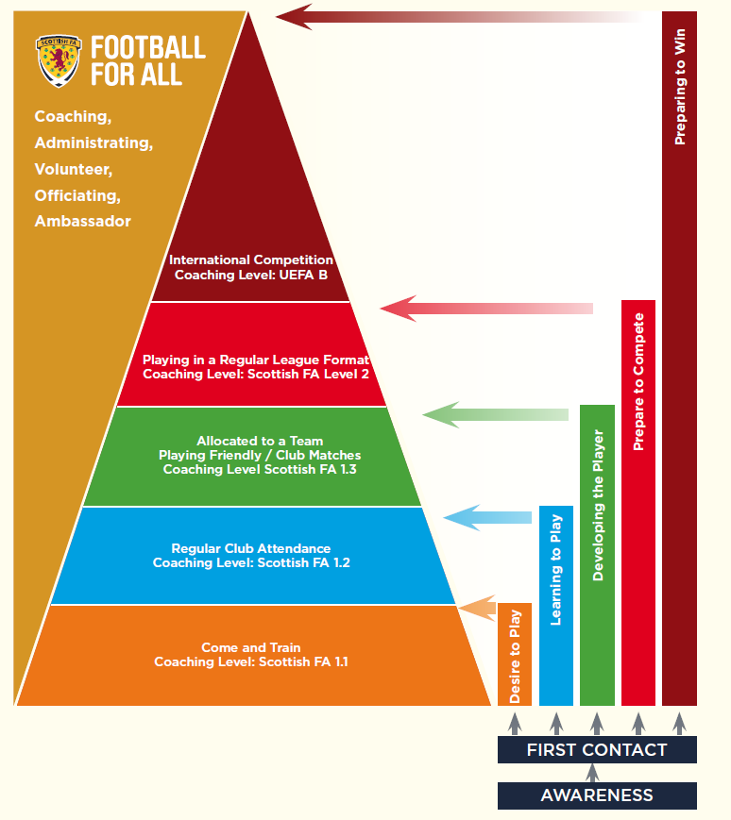

Safe Football

Safety Considerations
There are some health and safety considerations that coaches and parents/carers may need to take into account when a visually impaired person takes part in sport.

However, health and safety considerations should not be a barrier to including participants. Specific risks should be considered as part of the usual risk assessment for the activity and action taken to minimise any potential risks as much as possible.
Template risk assessment forms are available from British Blind Sport and the Scottish Football Association.

Fire Evacuation

Make sure that there is a procedure in place to support a visually impaired participant if they require it in a fire evacuation and that they know what it is, for example assigning a guide to provide assistance.

Insurance

Ensure that there is adequate insurance to protect you, your participants and your club. Having a visually impaired participant within your session will not affect your insurance cover.

Further Information

HSE – Health and Safety Executive http://www.hse.gov.uk/

Safeguarding Children, Young People and Vulnerable Adults

As a volunteer, coach, or member of staff it is vitally important to prioritise safeguarding the welfare of children and adults at risk. In this resource the term ‘children’ refers to children and young people under the age of 18.

Different Home Nations have different legislations regarding the safeguarding of children and adults at risk. If your centre is affiliated with a BEF member body, please refer to them for further information and guidance. Alternatively, you can get good advice from the Child Protection in Sport Unit (CPSU) or your local authority.

Anyone directly or indirectly involved with providing sport and physical activity opportunities have a responsibility to:
• Recognise signs of abuse and understand the impact of abuse.
• Respond in an appropriate manner to children and adults at risk who may disclose that they are being abused.
• Know where to go for further information.
• Take appropriate action if concerns are raised.
• Ensure a clear process is in place for staff/ volunteers to gain a disclosure check.
• Understand the need for photography, videography, and social media policies.

PVG
PVG (Scotland), help employers make safer recruitment decisions and prevent unsuitable people from working or volunteering with vulnerable groups, including children. Anyone working with children or adults at risk has a legal requirement to ensure appropriate checks are made.

Further Information
Disclosure Scotland https://www.mygov.scot/organisations/disclosure-scotland/
Child Protection in Sport Unit https://thecpsu.org.uk/
National Society Prevention of Cruelty to Children - www.nspcc.com
Childline - www.childline.org.uk

Clean Sport

British Blind Sport and our partners are committed to supporting and encouraging clean sport.

Doping in sport is a significant issue. Supporters and spectators question the honesty and ethics of the competition and may lose faith in the sport. Clean sport - free of doping - results in fair competition, with supporters understanding that only the athlete’s skill and ability is playing a role.

Along with affecting the integrity of competition, doping can have a significant impact on the health of athletes and can result in lasting health issues.

As a coach it is important that you share the values of clean sport and promote these values to your participants and the parents of participants to increase awareness of the seriousness of doping in sport.

UK Anti-Doping (UKAD) is the national organisation dedicated to protecting a culture of clean sport. The role and remit of UKAD includes:
• Raising awareness of the issues related to anti-doping.
• Ensuring sports bodies are compliant with the World Anti-Doping Code.
• The prevention of doping in sport through education programmes.
• Intelligence-led athlete testing across more than 40 Olympic, Paralympic and Professional Sports.

As a coach you need to:
• Understand the role of UKAD and where to go to access further information.
• Develop a coaching environment that nurtures a culture of personal excellence, rather than win at all costs.
• Promote clean sport.
• Provide necessary information, timely and appropriate to the level of athlete that you are working with.

UKAD offer an extensive education programme for coaches, support staff, athletes and parents. Visit www.ukad.org.uk for further information.

Reporting Doping

If you suspect doping in sport, contact UKADs anonymous and confidential Reporting Doping in Sport Hotline on 0800 032 2332.

Summary and Best Practice

Communication
- Good and clear communication is vital.
- Don’t assume all people with a visual impairment can’t see anything.
- Remember everyone is individual and every eye condition is different.
- Ask the participant what they can see and what support they need.
- Always identify and introduce yourself verbally, so that the participants become familiar with the sound of your voice.
- Don’t be afraid to use everyday language such as “see” or “look.”

Venue
- Help familiarise the visually impaired participant with the playing area and venue.
- Provide time for your visually impaired footballers to orientate themselves within the activity area.
- Ensure the activity area is well lit.
- Have sighted guides to support the participants around the venue.
- Describe venue hazards where necessary.

Demonstrations
- Use clear instructions and explanations.
- Verbalise your actions when describing techniques.
- Don’t rely on visual demonstrations.
- Use tactile demonstration where appropriate.
- Ask the participant questions to check they have understood your request.
- Don’t assume all participants will be able to do basic motor skills correctly.

Equipment
- When selecting equipment, think big, bright and bold!
- Consider the colour contrast of the equipment and surface you are using.
- Use audible equipment where possible.

Further Reading

EFDS Inclusive Communications Guide – Access for all: inclusive communications http://www.efds.co.uk/resources/case_studies/2697_access_for_all_efds_inclusive_communications_guide

EFDS Talk To Me Research
http://www.efds.co.uk/how-we-help/research/1878-talk-to-me-october-2014

Media Guide to reporting on persons with an impairment; International Paralympic Committee http://www.paralympic.org/sites/default/files/document/141027103527844_2014_10_31+guide+to+reporting+on+persons+with+an+impairment.pdf

British Blind Sport: A Vision for 2020 and Beyond Strategy
http://www.britishblindsport.org.uk/files/2018-01-03/BBSStrategicPlan-2018andbeyond002.pdf

Scottish FA strategy
https://www.scottishfa.co.uk/scottish-fa/organisation/working-at-the-scottish-fa/our-strategy-values/

Scottish Disability Sport Strategy: Inspiring Through Inclusion 2017-2021
https://www.scottishdisabilitysport.com/wp-content/uploads/2016/07/SDS-Strategy-Plan-2017-HD-Final.pdf

About British Blind Sport and the Scottish Football Association

About British Blind Sport

British Blind Sport helps blind and partially sighted people get active and play sport. Sport and recreational activities can enhance the lives of people with visual impairments, by improving their health and increasing their social interaction. We encourage adults and children to participate in activities at all levels from grassroots to the Paralympic Games. British Blind Sport works across many areas to increase participation and ensure visually impaired people have equal access and a high quality experience of sport.
Key work areas include:
• Competitions and leagues.
• National events.
• Creating local opportunities in partnership with local sports deliverers.
• Educating clubs, coaches and facility providers.
British Blind Sport is reliant on donations and the goodwill of the general public to deliver its services. Please donate now at www.britishblindsport.org.uk.

About the Scottish Football Association (SFA)

The Scottish FA is the governing body for football in Scotland. It is a members’ organisation,

The Scottish FA is a member of UEFA and FIFA and holds a position on the International Football Association Board (IFAB), the body that determines the Laws of the Game.

The Scottish FA exists to promote, foster and develop the game at all levels in this country.

Founded in 1873, Scottish football’s governing body has recently undergone the most radical changes in its history, enabling us to lead the game into a new era. The launch of our strategic plan Scotland United: A 2020 Vision outlines the ambition, values and goals that underpin the organisation and its many facets.

The plan encompasses four strategic pillars:
• Perform and Win
• Strong Quality Growth
• Better financial returns
• Respected and Trusted to Lead

Contact Details

British Blind Sport
Plato Close
Pure Offices
Tachbrook Park
Leamington Spa
Warwickshire
CV34 6WE
Phone: 01926 424247
Web: www.britishblindsport.org.uk
Email: info@britishblindsport.org.uk
Registered charity number: 1168093
Company limited by guarantee: 10009918

Scottish Football Association
Hampden Park
Glasgow
G42 9AY
Phone: 0141 6166000
Web: https://www.scottishfa.co.uk/
Email: info@scottishfa.co.uk
Limited company number: SC005453

The intellectual property of this resource remains the property of British Blind Sport. Copyright of the images remain with the photographer and/or organisations as agreed.

